22.May.2023
To,
Drug Controller General of India
Directorate General of Health and Family Welfare,
Government of India,
FDA Bhawan, ITO,
Kotla Road, New Delhi-110002

Sub: Covering Letter

Ref: Application for Test License for Manufacturing of RT-PCR Kits.

We would like to apply for the grant of MD-12 Test license for manufacturing of the following products as per below list:

S. No. | Products | Class
1 | {productName} | {productClass}

We are submitting herewith the following documents for your kind perusal.

- Covering Letter
- Brief description of medical device for applied products.
- Undertaking for applied products.
- List of Equipment’s used in manufacturing of RT-PCR Kit.
- List of qualified personnel involved.
- Justification of quality proposed to be manufactured.
- Schematic plan of premises.
- Certification of site with detailed raw component.
- Details description of how the raw material will be procured so that the entire process is scrutinized.
You are requested to grant the approval in MD-12 for the applied product.

Thanking you

Yours truly,
{manufacturerName}

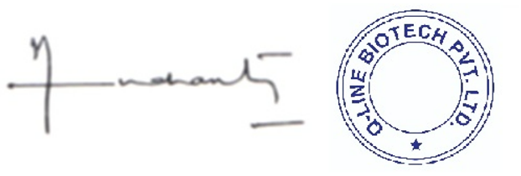

Director
{directorName}

